- import maya.cmds as cmds

# delete everything
cmds.select(all=True)
cmds.delete()

# create ground
ground = cmds.polyPlane(w=30, h=30, sx=30, sy=30, name="ground")[0]
cmds.move(0,0,0, ground)

# create 4 walls
walls = []
walls.append(cmds.polyCube(w=30, h=6, d=0.5, name="wall_front")[0])
cmds.move(0,3,15, walls[-1])

walls.append(cmds.polyCube(w=30, h=6, d=0.5, name="wall_back")[0])
cmds.move(0,3,-15, walls[-1])

walls.append(cmds.polyCube(w=0.5, h=6, d=30, name="wall_left")[0])
cmds.move(-15,3,0, walls[-1])

walls.append(cmds.polyCube(w=0.5, h=6, d=30, name="wall_right")[0])
cmds.move(15,3,0, walls[-1])

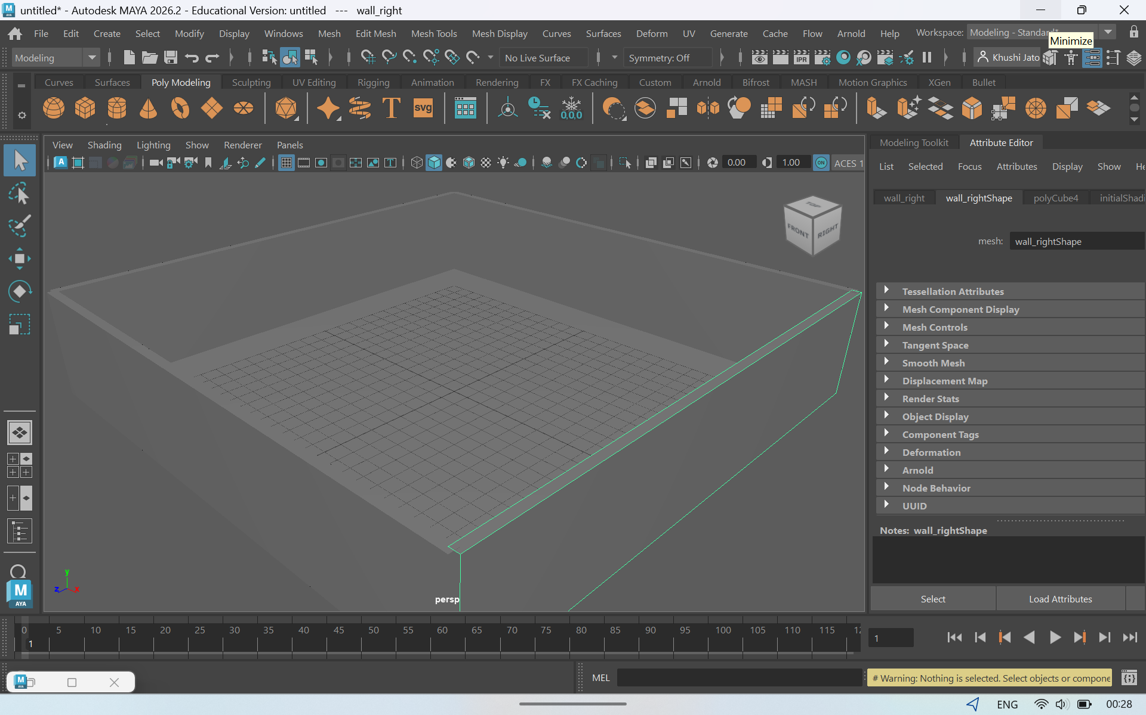

- ball_positions = [(-8, 8, -5), (-3, 8, 6), (2, 8, -2), (6, 8, 4), (10, 8, -6)]
balls = []

for i, pos in enumerate(ball_positions):
b = cmds.polySphere(r=0.7, name=f"ball_{i+1}")[0]
cmds.move(pos[0], pos[1], pos[2], b)
balls.append(b)

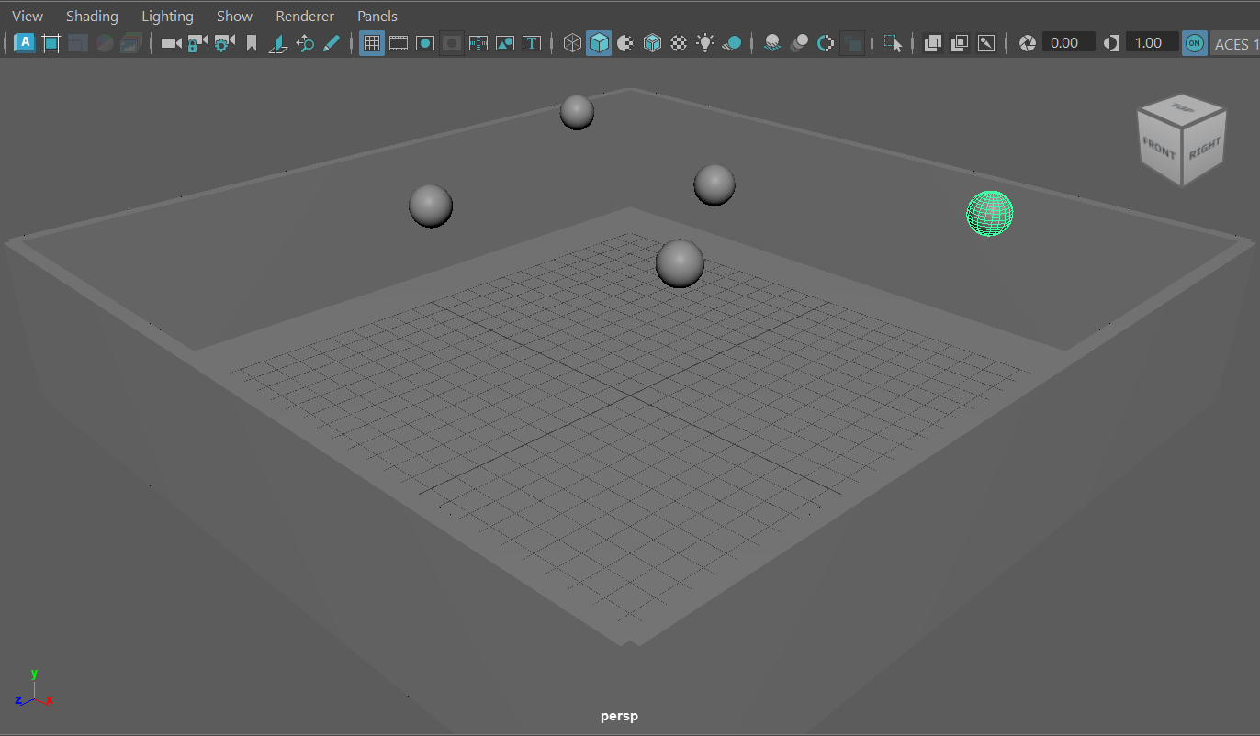
- import random

- start_times = [1, 20, 40, 60, 80] # frames when each ball begins falling

- for i, b in enumerate(balls):
- start = start_times[i]
- end = start + 40 # fall duration

- # Set keyframes
- cmds.setKeyframe(b, attribute="translateY", t=start, v=8)
- cmds.setKeyframe(b, attribute="translateY", t=end, v=0)

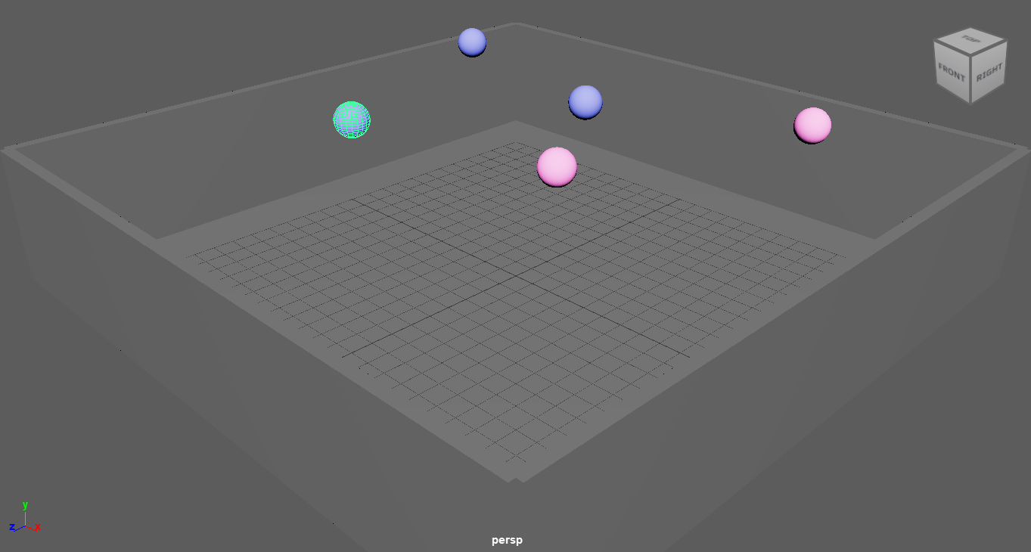

4) from maya import cmds

# delete old paddle if exists
if cmds.objExists("paddle"):
cmds.delete("paddle")

# create a simple rectangular paddle
p = cmds.polyCube(w=4, h=0.5, d=2, name="paddle")[0]

# move slightly above ground
cmds.move(0, 0.5, 0, p)

print("Paddle created:", p)

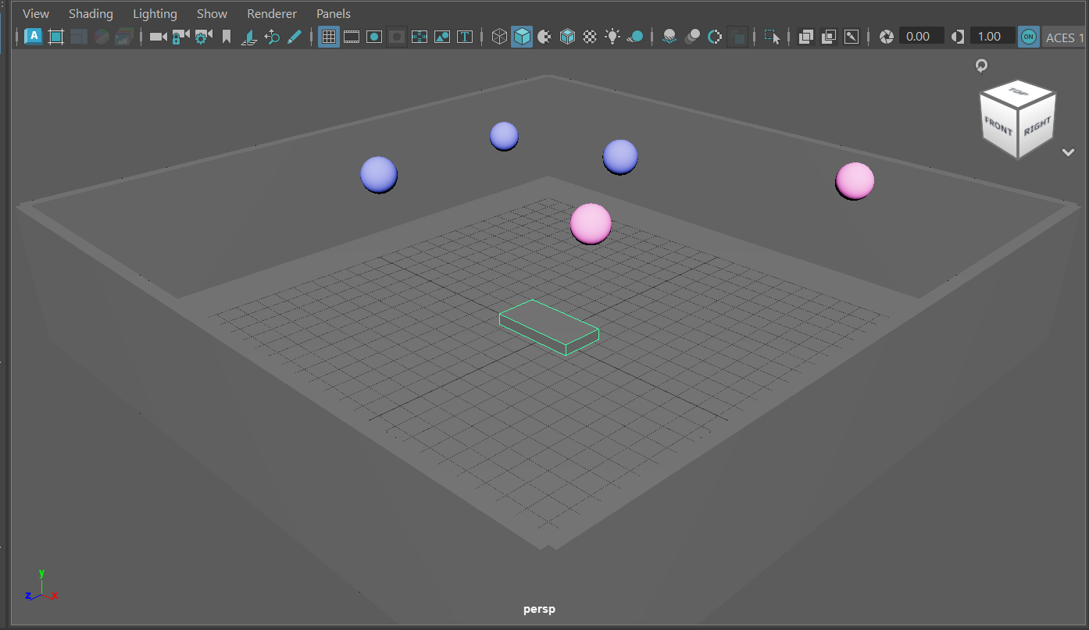

5)
# Maya Python: simple ball-catcher demo
# Paste this into Script Editor (Python tab) and Run

import maya.cmds as cmds
import math

# ---------- cleanup helper ----------
def cleanup_game():
# delete old balls, paddle, UI and scriptJob
for n in cmds.ls('ball*') + cmds.ls('paddle'):
try:
cmds.delete(n)
except:
pass
# remove named scriptJob if present
jobs = cmds.scriptJob(listJobs=True) or []
for j in jobs:
if 'game_time_changed' in j:
# j looks like "123: timeChanged"
try:
jid = int(j.split(':')[0])
cmds.scriptJob(kill=jid, force=True)
except:
pass
# close window if open
if cmds.window('paddleWin', exists=True):
cmds.deleteUI('paddleWin')

cleanup_game()

# ---------- create paddle ----------
paddle = cmds.polyCube(w=4, h=0.4, d=2, name='paddle')[0]
cmds.move(0, 0.5, 5, paddle) # move a bit above ground and toward the front (adjust Z as you like)
cmds.setAttr(paddle + ".visibility", 1)

# ---------- functions to move paddle ----------
def move_paddle(dx=0, dz=0):
if cmds.objExists('paddle'):
cmds.move(dx, 0, dz, 'paddle', relative=True)
else:
cmds.warning("Paddle not found.")

# ---------- create colored balls and animate falling ----------
# positions (x,z) for five balls (spread across the scene)
positions = [(-8, -2), (-4, -2), (0, -2), (4, -2), (8, -2)]
start_offsets = [0, 12, 26, 40, 60] # different delays in frames for each ball
fall_duration = 40 # frames taken to fall
colors = [(0.9,0.3,0.6), (0.2,0.7,0.3), (0.3,0.5,1.0), (1.0,0.6,0.2), (0.6,0.4,1.0)]

balls = []
for i, pos in enumerate(positions):
name = "ball{}".format(i+1)
sph = cmds.polySphere(r=0.8, name=name)[0]
balls.append(sph)
# place horizontally, and high on Y
start_frame = 1 + start_offsets[i]
end_frame = start_frame + fall_duration
x, z = pos
# set initial transform
cmds.setAttr(sph + ".translateX", x)
cmds.setAttr(sph + ".translateZ", z)
cmds.setAttr(sph + ".translateY", 20) # starting height
# keyframe start and end Y so it falls
cmds.setKeyframe(sph, attribute='translateY', time=start_frame, value=20)
cmds.setKeyframe(sph, attribute='translateY', time=end_frame, value=0.6) # ground contact
# make a simple lambert shader per ball and color it
shader = cmds.shadingNode('lambert', asShader=True, name='ballShader_{}'.format(i+1))
cmds.setAttr(shader + '.color', colors[i][0], colors[i][1], colors[i][2], type='double3')
sg = cmds.sets(renderable=True, noSurfaceShader=True, empty=True, name='ballSG_{}'.format(i+1))
cmds.connectAttr(shader + '.outColor', sg + '.surfaceShader', force=True)
cmds.sets(sph, edit=True, forceElement=sg)

# ---------- simple collision detection ----------
_game_state = {'score':0}

def check_collisions():
# called every time the timeline changes
if not cmds.objExists('paddle'):
return
px, py, pz = cmds.xform('paddle', q=True, ws=True, translation=True)
remove_list = []
for b in cmds.ls('ball*') or []:
if not cmds.objExists(b):
continue
bx, by, bz = cmds.xform(b, q=True, ws=True, translation=True)
dist = math.sqrt((bx-px)**2 + (by-py)**2 + (bz-pz)**2)
threshold = 2.0 # collision threshold (tweak as needed)
if dist < threshold:
# collision! delete the ball and increment score
try:
cmds.delete(b)
except:
pass
_game_state['score'] += 1
print("Caught:", b, " Score:", _game_state['score'])

# create a scriptJob to run check_collisions() on timeChanged
# remove existing similarly named jobs to avoid duplicates
for job in (cmds.scriptJob(listJobs=True) or []):
if 'game_time_changed' in job:
try:
jid = int(job.split(':')[0])
cmds.scriptJob(kill=jid, force=True)
except:
pass

def _bind_check_event():
jid = cmds.scriptJob(event=["timeChanged", 'python("check_collisions()")'], protected=True)
# tag the job line so we can find it later in listJobs
# maya listJobs does not store a name per job so we just keep a reference in a hidden node
if not cmds.objExists('gameHelper'):
cmds.createNode('transform', name='gameHelper', skipSelect=True)
cmds.addAttr('gameHelper', longName='gameJobId', dt='string')
cmds.setAttr('gameHelper.gameJobId', str(jid), type='string')
print("Collision check job created id:", jid, "(fires on timeline change)")

_bind_check_event()

# ---------- simple UI for paddle control ----------
if cmds.window('paddleWin', exists=True):
cmds.deleteUI('paddleWin')
win = cmds.window('paddleWin', title='Paddle Controls', widthHeight=(260,90))
cmds.columnLayout(adj=True)
cmds.text("Move paddle", height=20)
cmds.rowLayout(nc=3)
cmds.button(label='← Left', command=lambda *a: move_paddle(-2,0))
cmds.button(label='→ Right', command=lambda *a: move_paddle(2,0))
cmds.setParent('..')
cmds.rowLayout(nc=3)
cmds.button(label='↑ Forward', command=lambda *a: move_paddle(0,-2))
cmds.button(label='↓ Back', command=lambda *a: move_paddle(0,2))
cmds.setParent('..')
cmds.showWindow(win)

print("Game setup done. Use the small Paddle Controls window to move the paddle.")
print("Play the timeline (press Play) to watch balls fall. Score prints when a catch occurs.")

# ---------- helper to delete any remaining balls manually ----------
def delete_all_balls():
for b in cmds.ls('ball*') or []:
try:
cmds.delete(b)
except:
pass
_game_state['score'] = 0
print("All balls deleted. Score reset.")
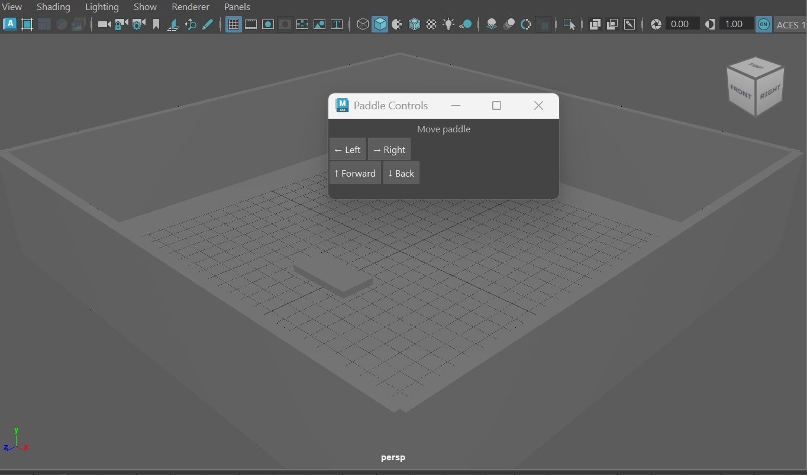

6)
import maya.cmds as cmds
import random
import math

# ---------- User tweakables ----------
num_balls = 5
start_height = 15
end_height = 0
min_x, max_x = -8, 8 # X range
min_z, max_z = -6, 6 # Z range
min_delay, max_delay = 0, 90
fall_duration = 140 # increase for slower fall
min_separation = 2.0 # minimum distance between ball centers (XZ plane)
shader_colors = [
(0.95, 0.5, 0.7),
(0.3, 0.9, 0.55),
(0.45, 0.6, 1.0),
(1.0, 0.85, 0.45),
(0.8, 0.45, 0.95)
]
# -------------------------------------

# delete any previous balls named ball1..ballN or ball*
for n in cmds.ls('ball*') or []:
try:
cmds.delete(n)
except:
pass

# generate separated positions in XZ plane
positions = []
attempts = 0
while len(positions) < num_balls and attempts < 5000:
attempts += 1
x = random.uniform(min_x, max_x)
z = random.uniform(min_z, max_z)
ok = True
for (px, pz) in positions:
if math.hypot(px - x, pz - z) < min_separation:
ok = False
break
if ok:
positions.append((x, z))

if len(positions) < num_balls:
cmds.warning("Could not place all balls with requested separation; placed %d/%d" % (len(positions), num_balls))

# create balls at the computed positions
balls = []
for i, (x, z) in enumerate(positions, start=1):
name = f"ball{i}"
b = cmds.polySphere(r=0.8, name=name)[0]
cmds.setAttr(b + ".translateX", x)
cmds.setAttr(b + ".translateZ", z)
cmds.setAttr(b + ".translateY", start_height)
balls.append(b)

# create shaders and assign colors
for i, b in enumerate(balls):
col = shader_colors[i % len(shader_colors)]
shader = cmds.shadingNode('lambert', asShader=True, name=f"ballShader_{i+1}")
sg = cmds.sets(renderable=True, noSurfaceShader=True, empty=True, name=f"ballSG_{i+1}")
cmds.connectAttr(shader + ".outColor", sg + ".surfaceShader", f=True)
cmds.setAttr(shader + ".color", col[0], col[1], col[2], type="double3")
cmds.sets(b, e=True, forceElement=sg)

# animate falling with random start delays
current = int(cmds.currentTime(q=True))
for i, b in enumerate(balls):
delay = random.randint(min_delay, max_delay)
start_frame = current + delay
end_frame = start_frame + fall_duration
cmds.setKeyframe(b, attribute='translateY', time=start_frame, value=start_height)
cmds.setKeyframe(b, attribute='translateY', time=end_frame, value=end_height)

# adjust playback range so you can see all the falls
min_play = current
max_play = current + max_delay + fall_duration + 10
cmds.playbackOptions(min=min_play, max=max_play)

print("Placed", len(balls), "balls at unique X,Z positions. Play timeline to see falling.")

